Report
Of
Development of AI-Based Applications for Language Translation, FAQ Handling, and Object Detection
Submitted
To
School of Computer Science and Engineering
IILM University, Greater Noida, U.P.
In partial fulfilment of the requirement of degree of
B.Tech CSE

By
Roll Number of Student: 25scs1003005194
Name of Student: SARIKA KUMARI
Batch: 2025-29

2025-29

CANDIDATE’S DECLARATION

I, SARIKA KUMARI, do hereby declare that the internship report titled “Development of AI-Based Applications for Language Translation, FAQ Handling, and Object Detection” has been completed by me to fulfil the requirement for the award of the degree of Bachelor of Technology in CSE. All the references have been quoted and I have not taken as such any material from any other source. I affirm to you that this report is my own and has not been submitted to any other institute for any degree/diploma requirement and further I shall be solely responsible for any kind of copyright violation in this regard.

Signature
Student Name: SARIKA KUMARI
Roll No.: 25scs1003005194

ACKNOWLEDGEMENT

I am using this opportunity to express my gratitude to everyone who supported me throughout the Internship Program. I am thankful for their aspiring guidance, invaluably constructive criticism and friendly advice during this work. I am sincerely grateful to them for sharing their truthful and illuminating views on a number of issues related to this work.
I express my gratitude to my parents for their blessings.

Signature
Student Name: SARIKA KUMARI
Roll No.: 25scs1003005194

INTERNSHIP COMPLETION CERTIFICATE

Paste / insert the scanned copy of the original Internship Completion Certificate issued by CodeAlpha (QR-verified, with Unique ID) on this page before final submission and printing.
This certificate is issued directly by CodeAlpha upon successful completion of the internship and cannot be generated independently — it must be obtained from CodeAlpha’s official completion process and attached here as an image or PDF page.

TABLE OF CONTENTS
Candidate’s Declaration i
Acknowledgement ii
Internship Completion Certificate iii
List of Tables v
List of Figures vi

Chapter 4: Project Description 1
4.1 Introduction 1
4.2 Organization Profile 1
4.3 Problem Statement 2
4.4 Project Objectives 2
4.5 Scope of the Project 3
4.6 Technologies and Tools Used 3
4.7 System Architecture 4
4.8 Methodology 5
4.9 Expected Outcomes 6
4.10 Certificates of Completion and Communication Proof 7
Chapter 5: Bibliography/References 8

LIST OF TABLES
Table 4.1: Technologies and Tools Used 3

LIST OF FIGURES
Figure 4.1: System Architecture — Language Translation Tool 4
Figure 4.2: System Architecture — Chatbot for FAQs 4
Figure 4.3: System Architecture — Object Detection and Tracking 4

CHAPTER 4: PROJECT DESCRIPTION
4.1 Introduction
Artificial Intelligence (AI) is increasingly used to automate everyday tasks that traditionally required significant manual effort — from translating language, to answering repetitive questions, to visually monitoring an environment. This report documents the work completed during an Artificial Intelligence internship undertaken with CodeAlpha, in which three independent AI-based applications were designed, built, and tested as part of a single internship engagement: a Language Translation Tool, a Chatbot for FAQs, and an Object Detection and Tracking system.
Each application addresses a distinct, practical problem using a different area of AI — natural language processing for translation and intent matching, and computer vision for real-time object detection — while sharing a common development approach: use well-established, pre-trained models and libraries, wrap them in a simple, usable interface, and validate the result against real inputs.
4.2 Organization Profile
CodeAlpha is a software development company that offers hands-on internship programmes across a range of emerging technology domains, including Artificial Intelligence, Web Development, and Android Development. Its internship model is built around practical, project-based tasks rather than purely theoretical learning: interns are given a task list for their chosen domain and are expected to independently research, build, and document working solutions.
The Artificial Intelligence track specifically focuses on giving interns hands-on experience with AI model development, machine learning workflows, and real-time data processing. On successful completion, CodeAlpha provides an internship offer letter, a QR-verified completion certificate, a unique ID certificate, a letter of recommendation based on performance, and placement/resume support.

4.3 Problem Statement
Three everyday problems were identified as suitable candidates for lightweight AI solutions during this internship. First, language differences continue to be a barrier to communication, and users often need a fast, simple way to translate text without relying on a full-fledged, paid software product. Second, organisations and individuals repeatedly answer the same set of frequently asked questions, which is time-consuming to do manually and does not scale well as the volume of queries grows. Third, monitoring a live video feed for specific objects and keeping track of them as they move is difficult to do manually in real time, but is a common requirement in surveillance, retail analytics, and traffic monitoring.
This internship set out to address each of these three problems with a focused, working AI application rather than a single combined system, so that each solution could be built and evaluated independently.
4.4 Project Objectives
- Build a web-based tool that translates user-entered text between languages in real time, with optional text-to-speech output.
- Build a chatbot that can answer frequently asked questions by matching a user's query to the closest question in a predefined FAQ dataset.
- Build a computer-vision system that detects objects in a live video stream and tracks each object across frames with a consistent identity.
- Use pre-trained models and well-supported open-source libraries wherever possible, rather than training models from scratch, to keep each solution practical to build within the internship timeline.
- Package each solution with a simple, usable interface so that its functionality can be demonstrated without requiring the end user to write or read code.

4.5 Scope of the Project
The scope of this internship was limited to building functional prototypes suitable for demonstration and academic evaluation, rather than production-grade, large-scale deployments. The Language Translation Tool supports text-to-text translation (with optional audio playback) across the languages supported by the underlying translation engine; it does not cover document or video translation. The FAQ Chatbot answers questions only from the FAQ dataset it is given; it is not an open-domain conversational agent and does not generate novel answers beyond its knowledge base. The Object Detection and Tracking system recognises the object classes supported by the pre-trained YOLOv8 model; it does not include training a custom object detector for domain-specific objects.
4.6 Technologies and Tools Used
Table 4.1 summarises the technologies and tools used across the three applications built during this internship.
Table 4.1: Technologies and Tools Used
Category | Tool / Library | Purpose
Programming Language | Python 3 | Core language for all three applications
Web UI Framework | Streamlit | Building simple, interactive front-ends
Translation | deep-translator (Google Translate engine) | Text translation between languages
Text-to-Speech | gTTS | Optional audio playback of translated text
NLP / Machine Learning | scikit-learn (TF-IDF, cosine similarity), pandas | FAQ question matching
Computer Vision | OpenCV, Ultralytics YOLOv8 | Real-time video capture and object detection
Object Tracking | ByteTrack | Assigning consistent IDs to tracked objects
Version Control | Git & GitHub | Source control and project submission

4.7 System Architecture
Figures 4.1 to 4.3 show the high-level data flow for each of the three applications.
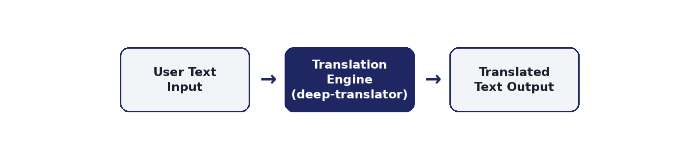
Figure 4.1: System Architecture — Language Translation Tool
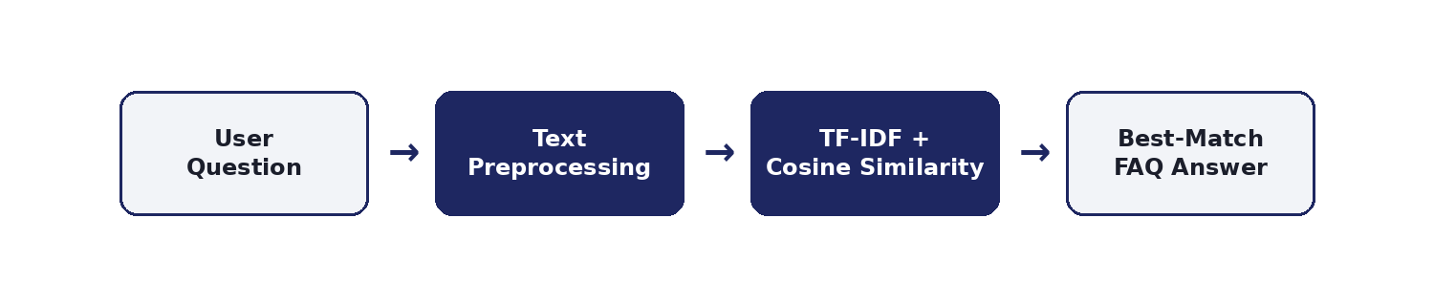
Figure 4.2: System Architecture — Chatbot for FAQs
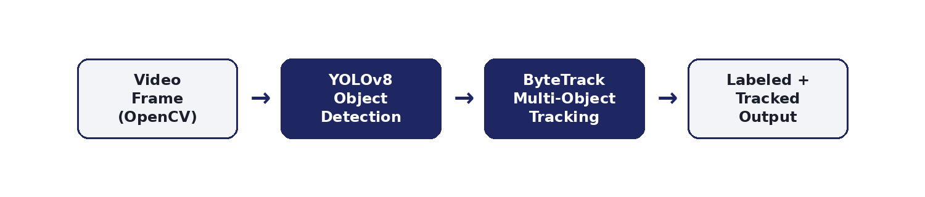
Figure 4.3: System Architecture — Object Detection and Tracking

4.8 Methodology
4.8.1 Language Translation Tool
- Built a Streamlit interface with a text input area and source/target language selectors.
- Used the deep-translator library (Google Translate engine) to send the input text and receive the translated output.
- Displayed the translated text in a read-only box for easy copying.
- Added an optional gTTS-based text-to-speech feature to play back the translated text as audio.
4.8.2 Chatbot for FAQs
- Collected a dataset of frequently asked questions and answers in CSV format.
- Preprocessed the text by lowercasing and removing punctuation, for both the FAQ dataset and incoming user queries.
- Converted questions into TF-IDF vectors using scikit-learn, and used cosine similarity to find the closest matching FAQ question to the user's query.
- Returned the answer for the best match above a similarity threshold, and a fallback message otherwise.
- Built a chat-style interface in Streamlit that preserves conversation history within a session.
4.8.3 Object Detection and Tracking
- Used OpenCV to capture real-time video from a webcam or a video file.
- Ran each frame through a pre-trained YOLOv8 model (Ultralytics) to detect objects.
- Applied the ByteTrack multi-object tracking algorithm to assign and persist a unique ID for each detected object across frames.
- Rendered bounding boxes, class labels, confidence scores, and tracking IDs on the live video output.

4.9 Expected Outcomes
The Language Translation Tool was expected to, and did, translate text across a wide range of languages in real time through a simple interface, with the optional audio playback improving accessibility for users who prefer listening over reading.
The Chatbot for FAQs was expected to correctly identify and return the most relevant FAQ answer for a range of user phrasings, without requiring a trained deep learning model. This outcome was achieved, and the lightweight TF-IDF-based approach also proved easy to extend with new FAQ entries.
The Object Detection and Tracking system was expected to reliably detect common objects in a live video stream and maintain a consistent tracking ID for each object as it moves across the frame. This was achieved using a pre-trained YOLOv8 model combined with ByteTrack, without the need to train a custom detector.
Beyond the individual applications, the internship strengthened practical skills in working with pre-trained AI models, NLP techniques such as TF-IDF and cosine similarity, real-time computer vision pipelines, and building simple, demonstrable interfaces with Streamlit — forming a solid foundation for further work in Artificial Intelligence.

4.10 Certificates of Completion and Communication Proof
Attach scanned copies or screenshots of the following in this section before final submission: the CodeAlpha Internship Offer Letter, the QR-verified Internship Completion Certificate, the Unique ID Certificate, and any email or LinkedIn communication proof relevant to the internship (e.g., the offer email and the task-submission confirmation).

CHAPTER 5: BIBLIOGRAPHY / REFERENCES
[1] CodeAlpha — Artificial Intelligence Internship Tasks & Instructions, CodeAlpha, 2026.
[2] Streamlit Documentation. Available: https://docs.streamlit.io
[3] deep-translator Documentation. Available: https://pypi.org/project/deep-translator/
[4] scikit-learn Documentation. Available: https://scikit-learn.org
[5] Ultralytics YOLOv8 Documentation. Available: https://docs.ultralytics.com
[6] OpenCV Documentation. Available: https://docs.opencv.org

